Assignment 1

AoN

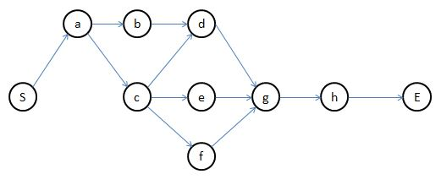

AoA

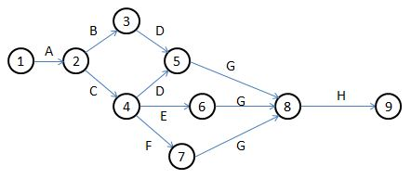

2.

AoN

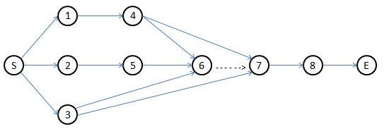

AoA

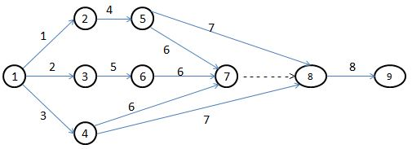

3.

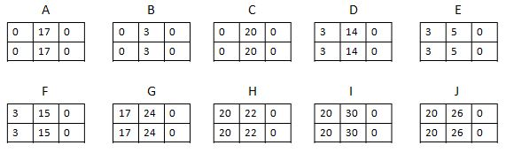

4.

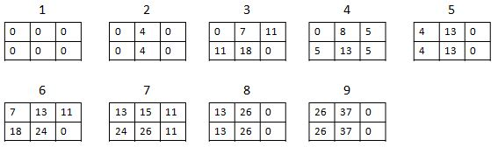

5.

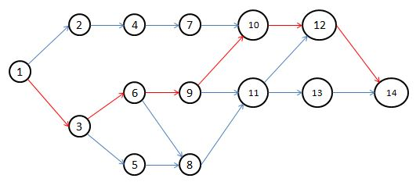

S= $\sqrt{σ_{1}^{2}}$ + $\sqrt{σ_{3}^{2}}$ + $\sqrt{σ_{6}^{2}}$ + $\sqrt{σ_{9}^{2}}$ + $\sqrt{σ_{10}^{2}}$ + $\sqrt{σ_{12}^{2}}$ + $\sqrt{σ_{14}^{2}}$

S= 2.46

P(T≤70) = ᵠ ($\frac{t- T_{E}}{S}$)

P(T≤70) = ᵠ ($\frac{70- 58}{2.46}$) = ᵠ (4.04) ≈ 99.99%